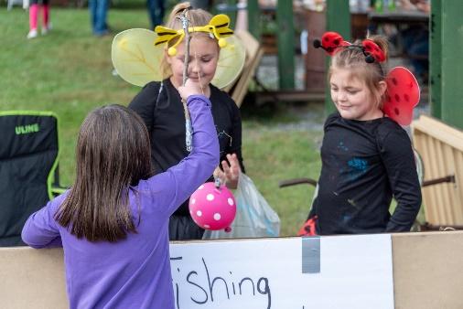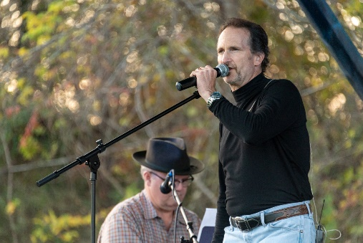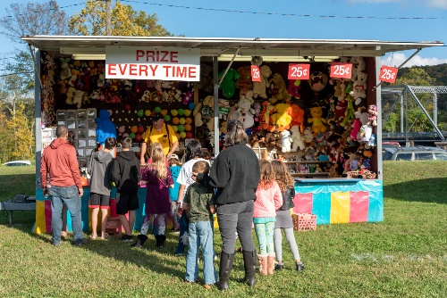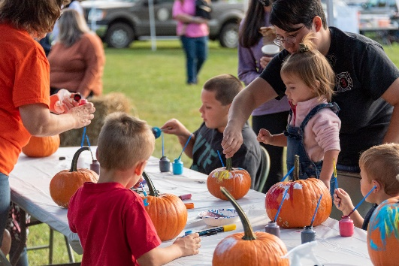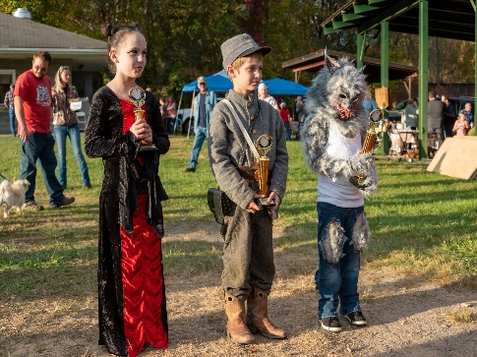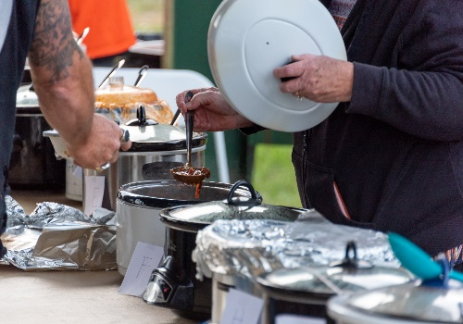
Live Music performed by Glen Shelton and Bruce Allen
Games, Vendors, Pumpkin Painting, Bounce House, Chili Cook-off, Children’s Costume Judging, Mechanical Bull riding, Strong Man Competition.
Delicious Food provided by the Goshen First Aid.
Lots of fun for the whole family!! Trophies given for Chili Cook-off, Costume Judging, Bull Riding and Strong Man Competitions.

